RENEWABLE ENERGY IN DOKUZ EYLÜL UNİVERSITY
DOKUZ EYLÜL UNIVERSITY SOLAR POWER PLANT PROJECT
Dokuz Eylül University will now produce its own renewable energy. The project will take place on 7 different campuses of our University, thanks to the solar panels, most of which have been installed.
Within the scope of the current project, in order to meet the energy needs of Dokuz Eylül University Campuses; 15 July Health and Art Campus 7500 kWe, Marine Sciences and Technology Institute 200 kWe, Economics and Administrative Sciences Faculty 930 kWe, Education Faculty 748 kWe, Tınaztepe Campus 5000 kWe, Torbalı Vocational School 806 kWe and Buca Yurt 160 kWe in 7 campuses, reaching a total of 15.204We power.

Installation work; aluminum profile assembly on the roof, panel assembly, DC cabling, inverter assembly, panel assembly, AC cabling and commissioning stages, in parking lot installations; concrete leg construction, steel construction assembly, panel assembly, DC cabling, inverter assembly, panel assembly, AC cabling and commissioning stages, in field installations; It consists of nailing of steel legs, panel assembly DC cabling, inverter assembly, panel assembly, AC cabling and commissioning.
Dokuz Eylul University Solar Power Plant project includes a power capacity of over 20MW. The total cost of the project is $18,000,000.

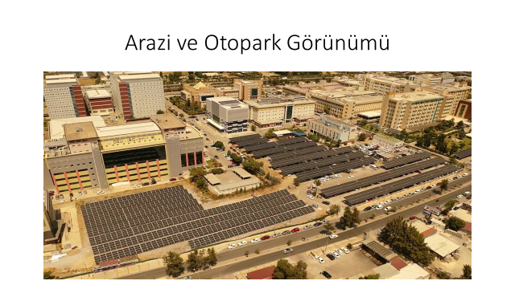
Solar energy pannels in 15 Temmuz Health Campus of DEU

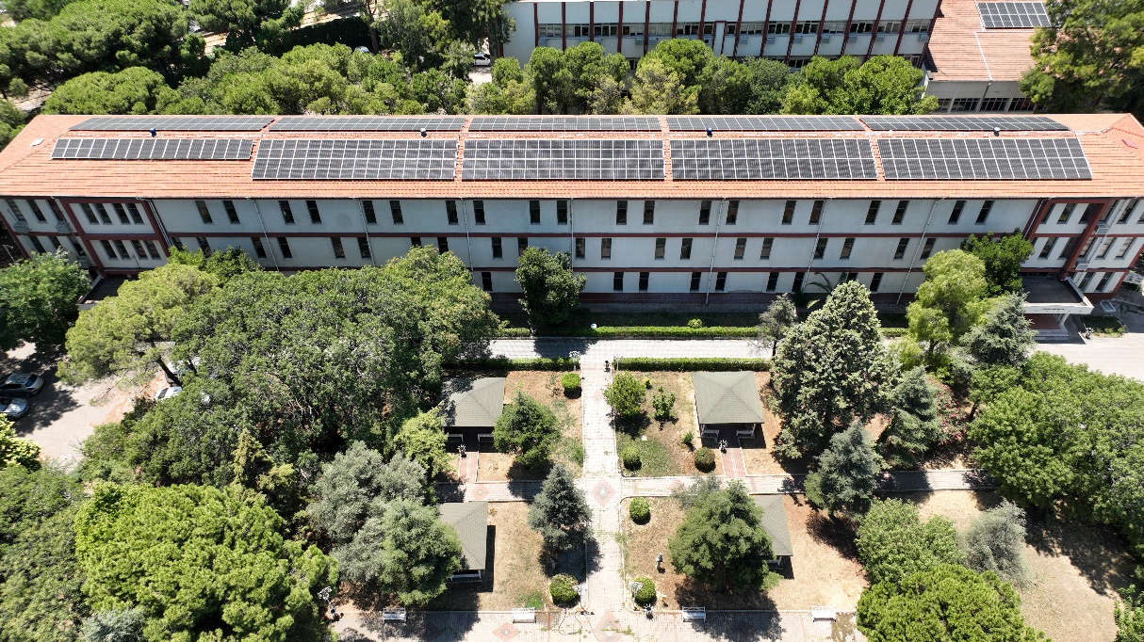
Solar energy pannels in Education Faculty Campus of DEU

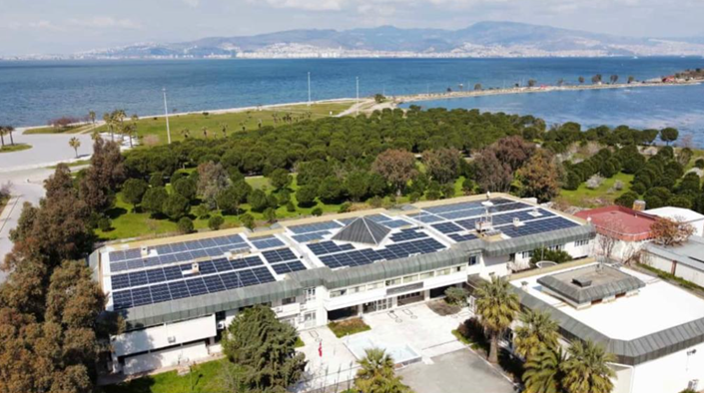
Solar energy pannels in Institute of Marine Sciences and Technology of DEU

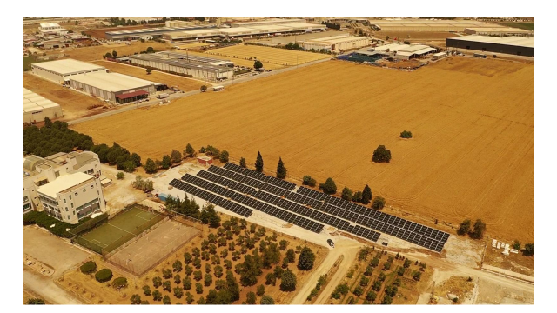
Solar energy pannels in Torbalı Vocational School of DEU
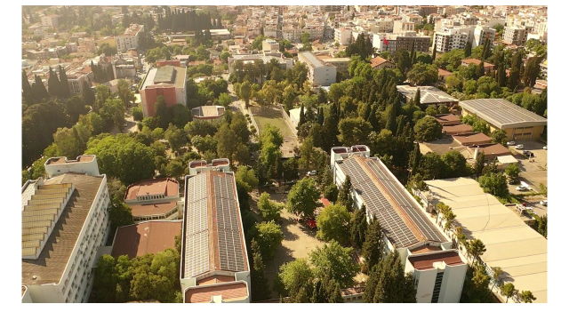
Solar energy pannels in Dokuzçeşmeler Campus of DEU
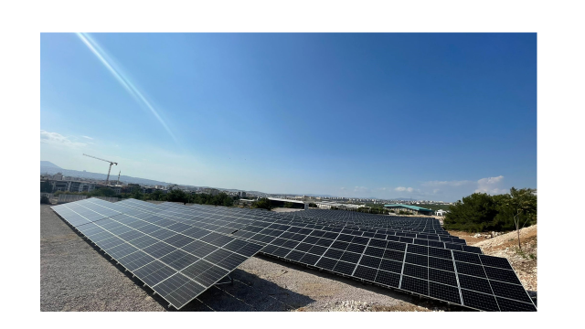
Solar energy pannels in Tınaztepe Campus of DEU

